***MYSQL***

***EXPLORATORY DATA ANALYSIS***

***On***

***Hospitals DataSet***

***By***

***Aman Rajbhar***

***Data Cleaning***

*DATABASE NAME------USE hospital_db;*

***Renaming/Atering The Table Column Names***

*ALTER TABLE facility*

*RENAME COLUMN `Facility.Name` TO Name,*

*RENAME COLUMN `Facility.City` TO City,*

*RENAME COLUMN `Facility.State` TO State,*

*RENAME COLUMN `Facility.Type` TO Type;*

*ALTER TABLE procedures*

*RENAME COLUMN `Procedure.Heart Attack.Cost` TO Heart_Attack_Cost,*

*RENAME COLUMN `Procedure.Heart Attack.Quality` TO Heart_Attack_Quality,*

*RENAME COLUMN `Procedure.Heart Attack.Value` TO Heart_Attack_Value,*

*RENAME COLUMN `Procedure.Heart Failure.Cost` TO Heart_Failure_Cost,*

*RENAME COLUMN `Procedure.Heart Failure.Quality` TO Heart_Failure_Quality,*

*RENAME COLUMN `Procedure.Heart Failure.Value` TO Heart_Failure_Value,*

*RENAME COLUMN `Procedure.Hip Knee.Cost` TO Hip_Knee_Cost,*

*RENAME COLUMN `Procedure.Hip Knee.Quality` TO Hip_Knee_Quality,*

*RENAME COLUMN `Procedure.Hip Knee.Value` TO Hip_Knee_Value,*

*RENAME COLUMN `Procedure.Pneumonia.Cost` TO Pneumonia_Cost,*

*RENAME COLUMN `Procedure.Pneumonia.Quality` TO Pneumonia_Quality,*

*RENAME COLUMN `Procedure.Pneumonia.Value` TO Pneumonia_Value;*

*ALTER TABLE rating*

*RENAME COLUMN `Rating.Effectiveness` TO Effectiveness,*

*RENAME COLUMN `Rating.Experience` TO Experience,*

*RENAME COLUMN `Rating.Imaging` TO Imaging,*

*RENAME COLUMN `Rating.Mortality` TO Mortality,*

*RENAME COLUMN `Rating.Overall` TO Overall,*

*RENAME COLUMN `Rating.Readmission` TO Readmission,*

*RENAME COLUMN `Rating.Safety` TO Safety,*

*RENAME COLUMN `Rating.Timeliness` TO Timeliness;*

***# Update Invalid Ratings (e.g., -1)***

*UPDATE rating*

*SET*

*rating.Overall = NULL*

*WHERE*

*rating.Overall = - 1;*

***#Remove Rows with Zero Procedure Costs***

*DELETE FROM procedures*

*WHERE*

*procedures.Heart_Attack_Cost = 0*

*OR procedures.Heart_Failure_Cost = 0*

*OR procedures.Hip_Knee_Cost = 0*

*OR procedures.Pneumonia_Cost = 0;*

***#Remove Rows with Zero Ratings***

*DELETE FROM rating*

*WHERE*

*Overall = 0*

*OR Mortality = 0*

*OR Safety = 0*

*OR Readmission = 0*

*OR Experience = 0*

*OR Effectiveness = 0*

*OR Timeliness = 0*

*OR Imaging = 0;*

*The ratings column that contains values such as 'above', 'below', 'same', and 'none',*

*i have* ***coverted them into ordinal values*** *like 3 for 'above', 2 for 'same', 1 for 'below', and 0 for 'none'*

*foe example:-*

*UPDATE rating*

*SET*

*rating.Mortality = 0*

*WHERE*

*rating.Mortality = 'None';*

*------*

*UPDATE rating*

*SET*

*rating.Mortality = 3*

*WHERE*

*rating.Mortality = 'above';*

***Data Exploration***

**DESCRIBE facility;**

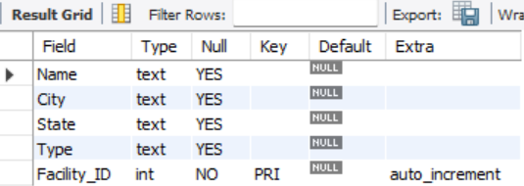

**DESCRIBE procedures;**

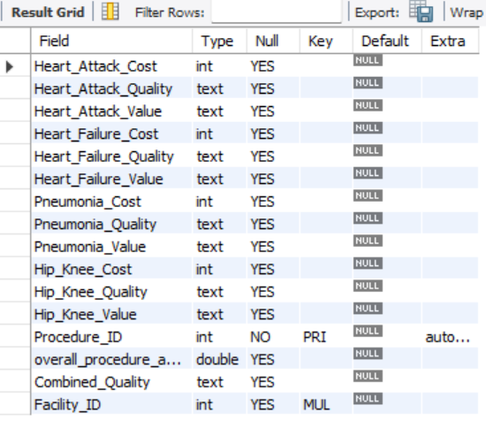

**DESCRIBE rating;**

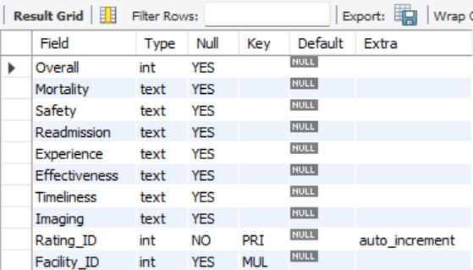

These queries provide the structure of the facility, procedures, and rating tables, listing columns, their data types, and constraints.

***#Count Total Rows and Distinct Facilities***

*SELECT*

*COUNT(*) AS Total_Rows,*

*COUNT(DISTINCT facility.Name) AS Distinct_Facility*

*FROM*

*facility;*



This query counts the total number of rows in the facility table and the number of distinct facilities by name.

***#Check Distribution of Facility Types***

*SELECT*

*facility.Type, COUNT(*) AS Count*

*FROM*

*facility*

*GROUP BY facility.Type*

*ORDER BY count DESC;*

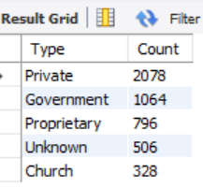

This query groups the facility table by Type and counts the number of facilities for each type, ordered from most to least frequent.

***# Summary Statistics for All Procedure Costs***

*SELECT*

*ROUND(AVG(procedures.Heart_Attack_Cost)) AS avg_heart_attack_cost,*

*MAX(procedures.Heart_Attack_Cost) AS max_heart_attack_cost,*

*MIN(procedures.Heart_Attack_Cost) AS min_heart_attack_cost,*

*ROUND(AVG(procedures.Heart_Failure_Cost)) AS avg_Heart_Failure_Cost,*

*MAX(procedures.Heart_Failure_Cost) AS max_Heart_Failure_Cost,*

*MIN(procedures.Heart_Failure_Cost) AS min_Heart_Failure_Cost*

*FROM*

*procedures;*



-----

*SELECT*

*ROUND(AVG(procedures.Hip_Knee_Cost)) AS avg_Hip_Knee_Cost,*

*MAX(procedures.Hip_Knee_Cost) AS max_Hip_Knee_Cost,*

*MIN(procedures.Hip_Knee_Cost) AS min_Hip_Knee_Cost*

*FROM*

*procedures;*

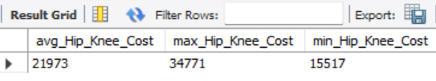

------

*SELECT*

*ROUND(AVG(procedures.Pneumonia_Cost)) AS avg_Pneumonia_Cost,*

*MAX(procedures.Pneumonia_Cost) AS max_Pneumonia_Cost,*

*MIN(procedures.Pneumonia_Cost) AS min_Pneumonia_Cost*

*FROM*

Procedures;

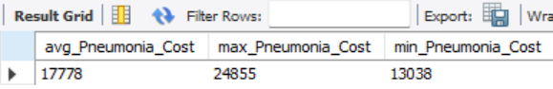

This query calculates the average, maximum, and minimum costs for heart attack,heart failure procedures,Hip Knee & Pneumonia.

***#Count of Ratings***

*SELECT*

*Overall, COUNT(*) AS count*

*FROM*

*rating*

*GROUP BY Overall*

*ORDER BY Overall;*

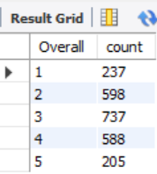

***Data Integration***

***#Create a New Column for Average Procedure Cost***

*alter table procedures*

*add column overall_procedure_avg_cost real;*

*UPDATE procedures*

*SET*

*overall_procedure_avg_cost = ((procedures.Heart_Attack_Cost + procedures.Heart_Failure_Cost*

*+ procedures.Hip_Knee_Cost + procedures.Pneumonia_Cost) / 4);*

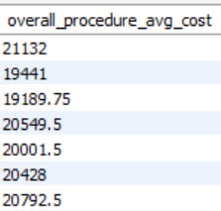

***# Combine Quality Ratings into a Single Column***

*ALTER TABLE procedures*

*ADD COLUMN Combined_Quality TEXT;*

*UPDATE procedures*

*SET Combined_Quality = concat(*

*procedures.Heart_Attack_Quality,', ',*

*procedures.Heart_Failure_Quality,', ',*

*procedures.Hip_Knee_Quality,', ',*

*procedures.Pneumonia_Quality);*

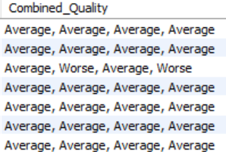

***Statistical Analysis***

***#Correlation Between Overall Rating and Procedure Costs***

*SELECT*

*rating.Overall,*

*AVG(procedures.Heart_Attack_Cost) AS avg_Heart_Attack_Cost,*

*AVG(procedures.Heart_Failure_Cost) AS avg_Heart_Failure_Cost,*

*AVG(procedures.Hip_Knee_Cost) AS avg_Hip_Knee_Cost,*

*AVG(procedures.Pneumonia_Cost) AS avg_Pneumonia_Cost*

*FROM*

*procedures*

*JOIN*

*rating ON procedures.Facility_ID = rating.Facility_ID*

*GROUP BY rating.Overall*

*ORDER BY rating.Overall;*

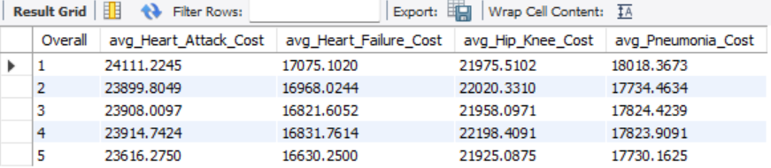

***#Distribution of Ratings by Facility Type***

*SELECT*

*facility.Type, rating.Overall, COUNT(*) AS count*

*FROM*

*facility*

*JOIN*

*rating ON facility.Facility_ID = rating.Facility_ID*

*GROUP BY facility.Type , rating.Overall*

*ORDER BY facility.Type , rating.Overall;*

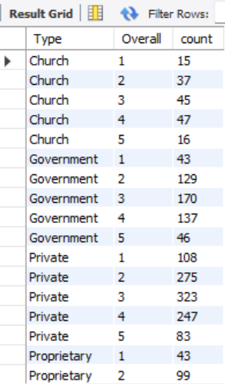

***Heart Attack Quality Distribution***

*SELECT*

*Heart_Attack_Quality, COUNT(*) AS count*

*FROM*

*procedures*

*GROUP BY Heart_Attack_Quality*

*ORDER BY count DESC;*

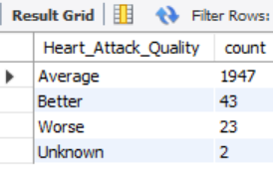

***#Top 10 Hospitals by Overall Rating***

*SELECT*

*f.Name, f.City, f.State, r.Overall*

*FROM*

*facility f*

*JOIN*

*rating r ON f.Facility_ID = r.Facility_ID*

*ORDER BY r.Overall DESC*

*LIMIT 10;*

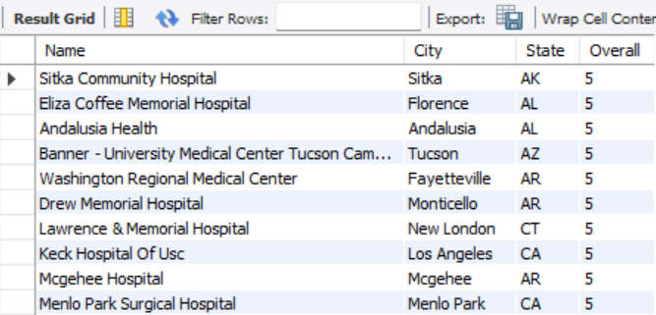

***Track Patient Records***

***#Total Number of Patients Per Facility***

*SELECT*

*Name, COUNT(*) AS Total_Patients*

*FROM*

*facility*

*GROUP BY Name*

*ORDER BY Total_patients DESC;*

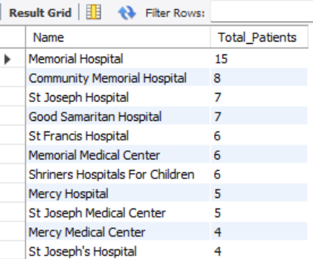

***#Patient Distribution by State:***

*SELECT*

*State, COUNT(*) AS Patient_Per_State*

*FROM*

*facility*

*GROUP BY State*

*ORDER BY Patient_Per_State DESC LIMIT 5*;

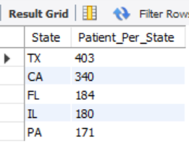

#HERE TX STAND FOR TEXAS WITH 403 TOTAL PATIENTS

--------------------------------------------------------------------------------------

***Evaluating Healthcare Metrics***

***#Average Rating of Facilities***:

*SELECT*

*facility.Name, AVG(rating.Overall) AS Avg_Overall_Rating*

*FROM*

*facility*

*JOIN*

*rating ON facility.Facility_ID = rating.Facility_ID*

*GROUP BY facility.Name*

*ORDER BY Avg_Overall_Rating DESC;*

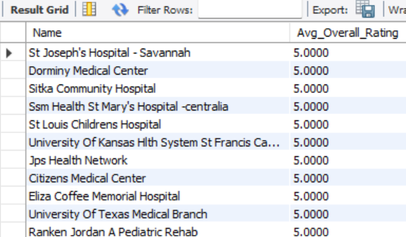

#***Identify Facilities with Low Safety Ratings***:

*SELECT*

*facility.Name,*

*facility.State,*

*rating.Safety AS low_safety_ratings*

*FROM*

*facility*

*JOIN*

*rating ON facility.Facility_ID = rating.Facility_ID*

*WHERE*

*Safety = 'Below'*

*GROUP BY facility.Name , facility.State , low_safety_ratings*;

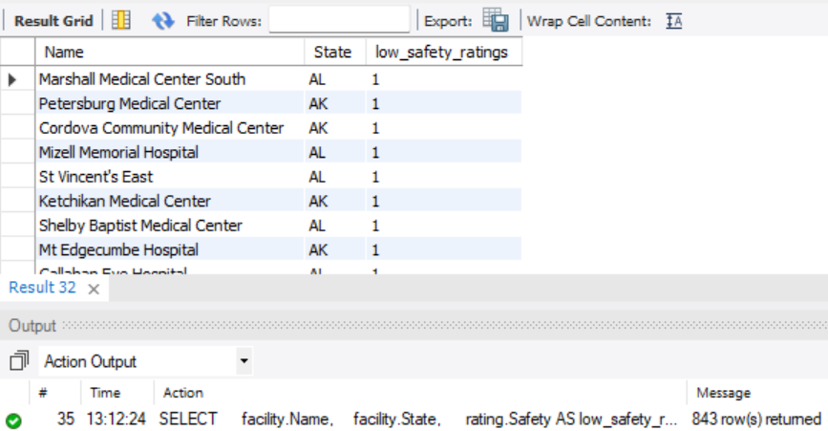

***#Calculate Average Cost of Each Procedures***:

*SELECT*

*f.Name, AVG(p.Heart_Attack_Cost) AS avg_heart_attack_cost*

*FROM*

*facility f*

*JOIN*

*procedures p ON f.Facility_ID = p.Facility_ID*

*GROUP BY f.Name*

*ORDER BY avg_heart_attack_cost DESC;*

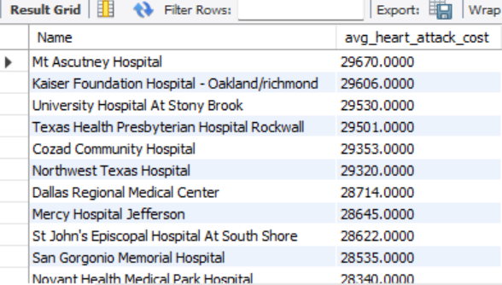

---------

*SELECT*

*f.Name, AVG(p.Heart_Failure_Cost) AS avg_Heart_Failure_Cost*

*FROM*

*facility f*

*JOIN*

*procedures p ON f.Facility_ID = p.Facility_ID*

*GROUP BY f.Name*

*ORDER BY avg_Heart_Failure_Cost DESC;*

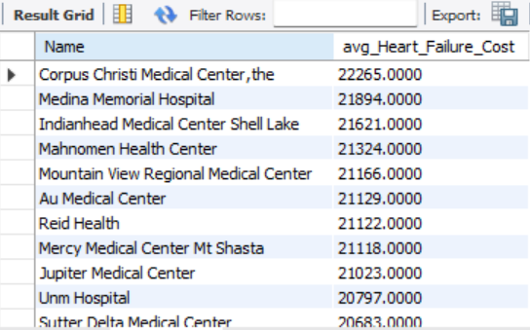

----------

*SELECT*

*f.Name, AVG(p.Hip_Knee_Cost) AS avg_Hip_Knee_Cost*

*FROM*

*facility f*

*JOIN*

*procedures p ON f.Facility_ID = p.Facility_ID*

*GROUP BY f.Name*

*ORDER BY avg_Hip_Knee_Cost DESC;*

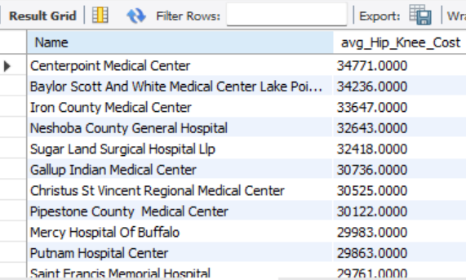

-----------

*SELECT*

*f.Name, AVG(p.Pneumonia_Cost) AS avg_Pneumonia_Cost*

*FROM*

*facility f*

*JOIN*

*procedures p ON f.Facility_ID = p.Facility_ID*

*GROUP BY f.Name*

*ORDER BY avg_Pneumonia_Cost DESC;*

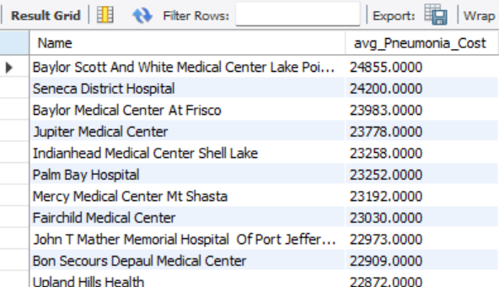

***Identify Areas for Improvement***

***#Facilities with High Readmission Rates:***

*SELECT DISTINCT*

*f.Name, f.State, r.Readmission, r.Overall AS Overall_Rating*

*FROM*

*facility f*

*JOIN*

*rating r ON f.Facility_ID = r.Facility_ID*

*WHERE*

*Readmission = 'Above' AND r.Overall = 5*

*ORDER BY Overall_Rating DESC;*

*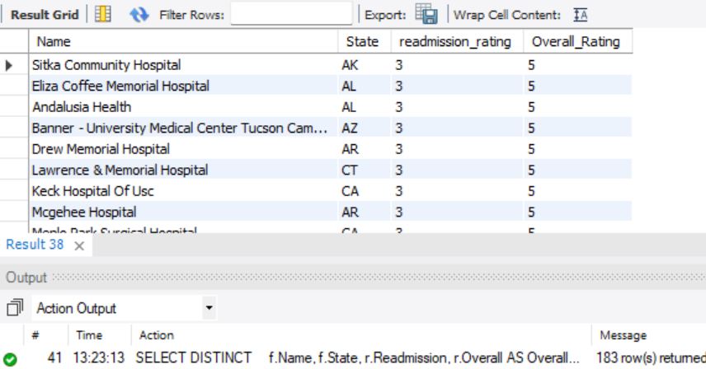 🡪 As you can see there are 183 rows with the oveall rating of 5 & readmiiision rating 3 on the scale of (1-3)*



***#Patient Distribution by State(TOP 5):***

*SELECT*

*f.State, COUNT(f.State) AS Patient_from_each_state*

*FROM*

*facility f*

*GROUP BY f.State*

*ORDER BY Patient_from_each_state DESC*

*LIMIT 5;*

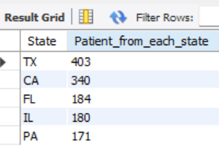

***Ranking Facilities by Procedure Cost***

***#Rank Facilities by Heart Attack Procedure Cost***

*SELECT*

*f.Name,*

*f.City,*

*f.State,*

*p.Heart_Attack_Cost,*

*RANK() OVER (ORDER BY p.Heart_Attack_Cost DESC) AS Cost_Rank*

*FROM*

*facility f*

*JOIN*

*procedures p*

*ON f.Facility_ID = p.Facility_ID*

*ORDER BY*

*Cost_Rank;*

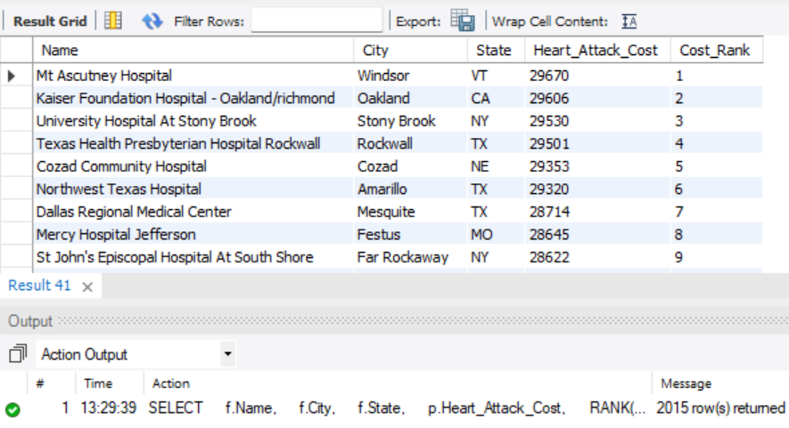

***#Ranking Facilities by Overall Rating within Each State***

*SELECT*

*f.Name,*

*f.State,*

*r.Overall AS overall_rating,*

*RANK() OVER (PARTITION BY f.State ORDER BY r.Overall) AS State_Rank*

*FROM*

*facility f*

*JOIN*

*rating r*

*ON f.Facility_ID = r.Facility_ID*

*ORDER BY*

f.State,

State_Rank;

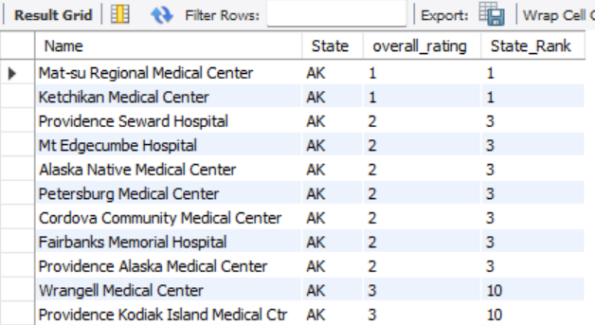

***Calculating Running Totals and Averages***

***#Running Total of Heart Attack Procedure Costs***

*SELECT*

*f.Name,*

*f.City,*

*f.State,*

*p.Heart_Attack_Cost,*

*SUM(p.Heart_Attack_Cost) OVER (ORDER BY p.Heart_Attack_Cost) AS Running_total_cost*

*FROM*

*facility f*

*JOIN*

*procedures p*

*ON f.Facility_ID = p.Facility_ID*

*ORDER BY*

*Running_total_cost;*

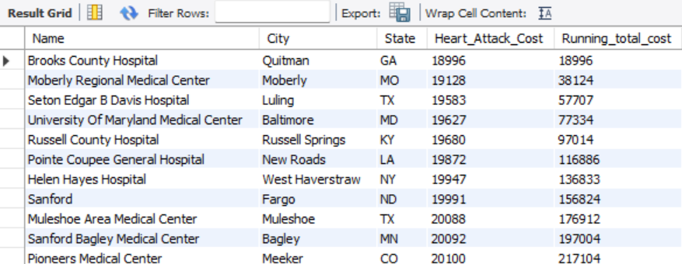

***#Moving Average of Heart Failure Procedure Cost***

*SELECT*

*f.Name,*

*f.City,*

*f.State,*

*p.Heart_Failure_Cost,*

*AVG(p.Heart_Failure_Cost) OVER (ORDER BY p.Heart_Failure_Cost) AS Moving_Avg_cost*

*FROM*

*facility f*

*JOIN*

*procedures p*

*ON f.Facility_ID = p.Facility_ID*

*ORDER BY*

*Moving_Avg_cost;*

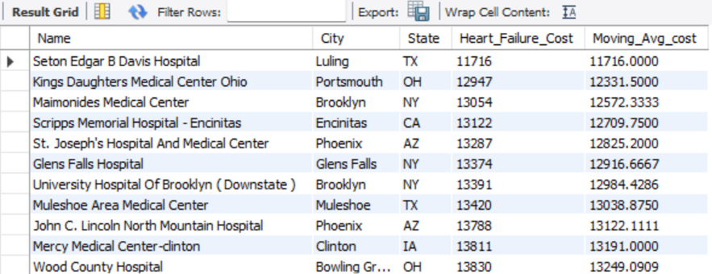

***Cumulative Metrics***

***#Cumulative Count of Facilities by Rating***

*SELECT*

*f.Name,*

*f.City,*

*f.State,*

*r.Overall,*

*COUNT(*) OVER (ORDER BY r.Overall) AS cumulative_count*

*FROM*

*facility f*

*JOIN*

*rating r*

*ON f.Facility_ID = r.Facility_ID*

*ORDER BY*

*cumulative_count;*

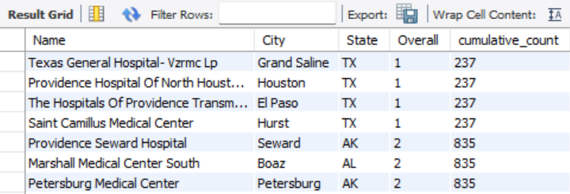

***#Cumulative Average of Procedure Costs by Facility Type***

*SELECT*

*f.Type,*

*f.Name,*

*p.Pneumonia_Cost,*

*AVG(p.Pneumonia_Cost) OVER (PARTITION BY f.Type ORDER BY f.Name) AS cumulative_avg_cost*

*FROM*

*facility f*

*JOIN*

*procedures p*

*ON f.Facility_ID = p.Facility_ID*

*ORDER BY*

*f.Type,*

*f.Name;*

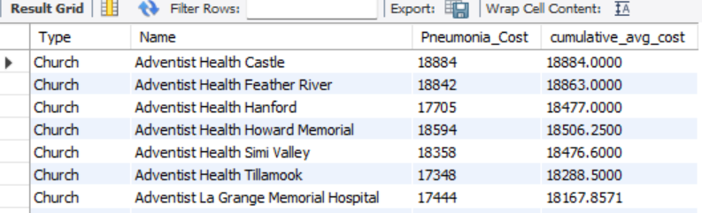

***Identifying Top and Bottom Performers***

***#Top 5 Facilities by Hip/Knee Procedure Cost within Each City***

*WITH RankedFacilities AS (*

*SELECT*

*f.Name,*

*f.City,*

*f.State,*

*p.Hip_Knee_Cost,*

*RANK() OVER (PARTITION BY f.City ORDER BY p.Hip_Knee_Cost DESC) AS City_cost_rank*

*FROM*

*procedures p*

*JOIN*

*facility f ON p.Facility_ID = f.Facility_ID*

*)*

*SELECT*

*Name,*

*City,*

*State,*

*Hip_Knee_Cost,*

*City_cost_rank*

*FROM*

*RankedFacilities*

*WHERE*

*City_cost_rank <= 5*

*ORDER BY*

*City, City_cost_rank limit 5;*

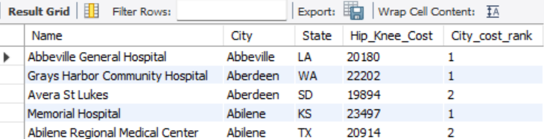

***#Bottom 5 Facilities by Overall Rating***

*WITH RankedFacilities AS (*

*SELECT*

*f.Name,*

*f.City,*

*f.State,*

*r.Overall,*

*RANK() OVER (ORDER BY r.Overall asc) AS rating_rank*

*FROM*

*rating r*

*JOIN*

*facility f ON r.Facility_ID = f.Facility_ID*

*)*

*SELECT*

*Name,*

*City,*

*State,*

*Overall,*

*rating_rank*

*FROM*

*RankedFacilities*

*WHERE*

*rating_rank <= 5*

*ORDER BY*

*City, rating_rank limit 5;*

